January 24, 2019

**From Agent to Advisor – Open Letter to the Travel Industry**

Dear Industry Colleagues:

In August 2018, our industry’s national trade association, the American Society of Travel Agents (ASTA), announced to the world that it had rebranded as the American Society of Travel *Advisors*. This name change, the Society’s first in almost 75 years, embodies the revitalization of our part of the travel industry that has been taking place for several years and sends a critical message to the traveling public and the broader industry.

Today’s travel agents are no longer mere booking intermediaries. They have become trusted advisors — akin to financial planners and CPAs — who make the overall travel experience better and provide both leisure and business travelers maximum value for their travel dollar. The term “advisor” not only more accurately describes the value our members provide to consumers but also serves as a distinct declaration of who we work for: the traveling public. What’s more exciting is that the consumer media and, more importantly, travelers themselves are embracing this shift from agent to advisor.

In order to fully realize the benefits of this change, however, it is critical that all industry stakeholders speak with one voice when it comes to describing our business. To that end, we are encouraging our member companies, supplier partners and anyone doing meaningful business through the travel advisor channel to add their name to the growing list of organizations (attached) that have made or are in the process of making the switch from “travel agent” to “travel advisor” in their consumer and trade communications.

We are experiencing a true renaissance in our industry, with consumers increasingly coming back to our members for the comparison shopping, unbiased advice, destination expertise and personal support that only a trusted travel advisor can provide. That said, terminology still matters and we hope you will join us as we move from agent to advisor.

Together in travel,

 

Zane Kerby Eric Altschul

President & CEO Chief Executive Officer

ASTA ABC Global Services

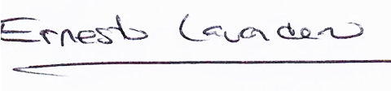 

Ernesto Lavandero Chris Dane

Director, U.S. Network President

American Express Travel Hickory Global Partners

cid:f_jr9owymn0 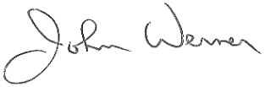

Bobby Godwin John Werner

Vice President President & COO

Leisure Travel Alliance MAST Travel Network

 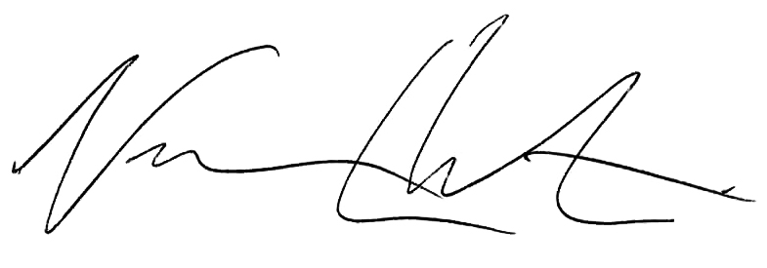

Alex Sharpe Ninan Chacko

President & CEO Chief Executive Officer

Signature Travel Network Travel Leaders Group

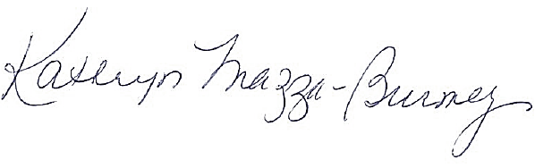 

Kathryn Mazza-Burney Matthew Upchurch

Executive Vice President, Sales Chairman & CEO

TRAVELSAVERS Virtuoso



Mike Estill

Chief Operating Officer

Western Assoc. of Travel Agencies (WESTA)

**Travel Industry Suppliers**

& Beyond

Accor Hotels

AIG Travel

Allianz

Ama Waterways

Amtrak Vacations

Apple Leisure Group

Auberge Resorts

Avis

Beds Online

Belmond

Carey International

Celebrity Cruises

ClubMed

Crystal Cruises

Dorchester Collection

Exeter International

G Adventures

Hawaii Visitors & Convention Bureau

Hertz

Hilton

Holland America Line

Hurtigruten

Hyatt Hotels

Insight Vacations

Island Destinations

Israel Ministry of Tourism

Journese

Leisure Connect

Luggage Free

Luxury Retreats

Marriott

Medjet

MGM Resorts International

National Transaction Corp.

Natural Habitat Adventures

Nobel House Hotels

Onefinestay

Oceania Cruises

Paul Gauguin Cruises

Pleasant Holidays

Ponant Cruises

Princess Cruises

Quark Expeditions

Railbookers

Regent Seven Seas Cruises

Roadtrips

Royal Caribbean Seabourn

Silvercar

Silversea

Special Needs Group

Star Clippers

Swain

Trafalgar

Travel 2

The Travel Corporation

UATP

Uniworld River Cruises

Viking Cruises

Virgin Limited (Hotels)

Walks

Way to Go Tours

Windstar Cruises

Yankee Holidays

**Consortia/Agency Networks**

ABC Global Services

American Express Travel

Ensemble Travel Group

Hickory Global Partners

Leisure Travel Alliance

MAST Travel Network

Signature Travel Network

Travel Leaders Group

TRAVELSAVERS

Virtuoso

WESTA